**Managing Kubernetes with Azure Kubernetes Service (AKS), Creating and managing AKS clusters, Scaling and upgrading AKS clusters**

Azure Kubernetes Service (AKS) simplifies Kubernetes management tasks, making it easier to deploy, manage, and scale containerized applications using Kubernetes. In this guide, we’ll walk through the process of creating an AKS cluster.

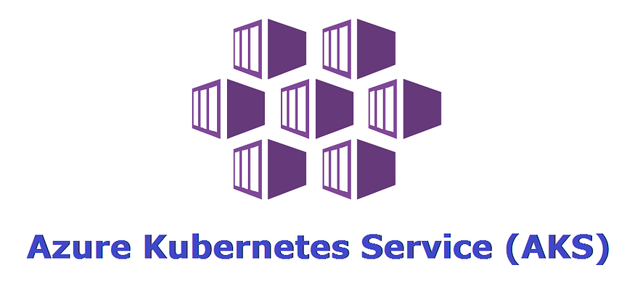

**Prerequisites**

Before we begin, ensure you have the following prerequisites:

* An Azure account. If you don’t have one, you can [*sign up for a free Azure account*](https://azure.microsoft.com/en-us/free/)

**Sign in to Azure Portal**

1. Open your web browser and navigate to the [*Azure Portal*](https://portal.azure.com/).
2. Sign in with your Azure account credentials.

**Create a Resource Group**

1. In the Azure Portal, click on “*Create a resource*” from the left-hand menu.
2. Search for “*Resource group*” and select “*Resource group*” from the results.
3. Click the “*Create*” button.
4. Enter a unique name for your resource group, such as “*MyAKSClusterResourceGroup*”
5. Choose a region for the resource group *(e.g., East US)*.
6. Click the “*Review + create*” button and then click “*Create*” to create the resource group.

**Create an AKS Cluster**

1. In the Azure Portal, click on “*Create a resource*” again.
2. Search for “*Kubernetes Service*” and select “*Kubernetes Service (AKS)*” from the results.
3. Click the “*Create*” button to start the AKS creation wizard.

**Basics**

1. In the “*Basics*” tab of the AKS creation wizard:

* Choose your *Azure subscription*.
* Select the resource group created before *(“MyAKSClusterResourceGroup”)*.
* Enter a unique name for your AKS cluster *(e.g., “MyAKSCluster”)*.
* Choose the region for your AKS cluster*(e.g., East US)*.
* Select the desired Kubernetes version *(e.g., 1.26.6)*.

2. Cluster Preset Configuration

* For practice purposes and development/testing tasks, select a cluster preset configuration that suits your needs, such as “Dev/Test.”
* This preset can provide you with predefined configurations optimized for these scenarios.

3. Availability Zones

* Specify the availability zones where your cluster nodes will be placed for increased resiliency.

Get Srija Anaparthy’s stories in your inbox

Join Medium for free to get updates from this writer.



Subscribe

4. AKS Pricing Tier

* AKS offers two pricing tiers for the managed Kubernetes control plane. Choose the pricing tier that best meets your needs.

5. Automatic upgrade Type:

* Choose an upgrade type to determine when the cluster will be upgraded based on new AKS and Kubernetes releases. (For example, you can choose “Enable with Patch” for recommended automatic upgrades.)

6. Authentication and Authorization:

* For *authentication and authorization*, you can choose to use *local accounts with Kubernetes RBAC*. This provides a native Kubernetes RBAC managed locally within your AKS cluster.

Click “*Next: Node Pools*” to proceed.

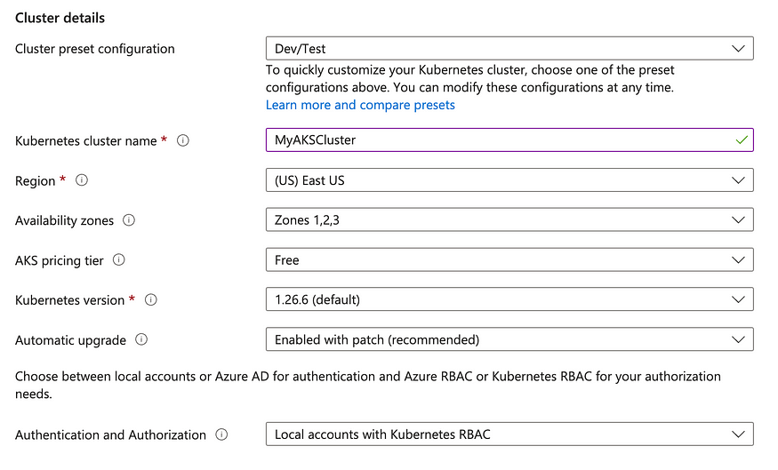

**Node Pool**

1. You can add or customize node pools based on your application requirements.
2. Define the number of nodes, VM size, and other settings for your node pool.

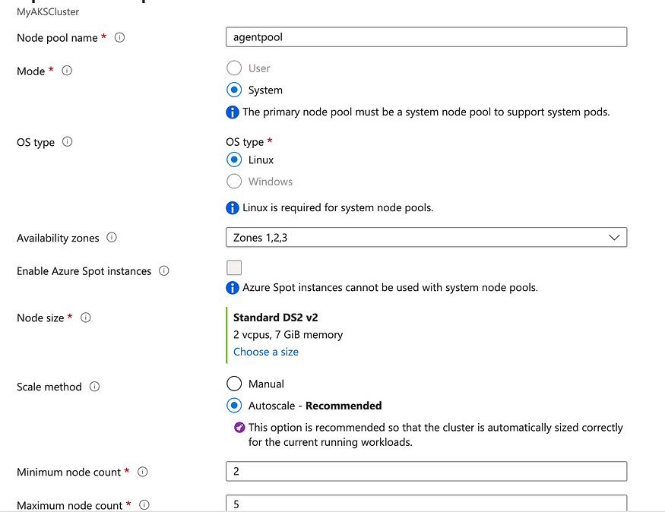

Click “*Next: Networking*” when you’re ready to proceed.

**Networking**

* Configure the networking settings for your AKS cluster. The default settings are usually sufficient for most use cases.

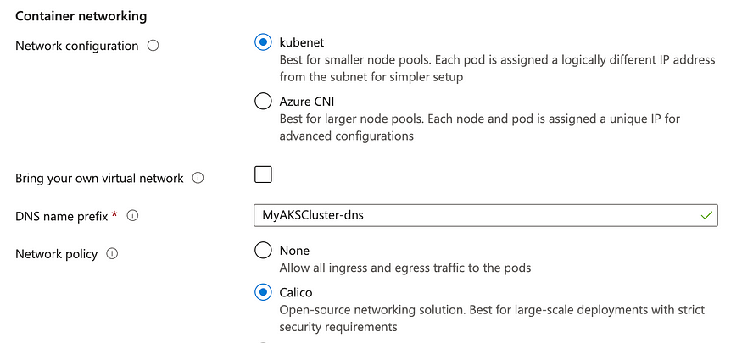

**Integrations**

1. Configure integrations with Azure services and features.
2. You can enable Azure Container Registry integration, Azure Policy, and more.

Click “Next: Monitoring” when you’re done.

**Monitoring**

* Enable monitoring if you want to use Azure Monitor and Azure Log Analytics for cluster monitoring and diagnostics.

Click “Next: Scaling” when you’re done.

**Tags**

1. Add tags to your AKS cluster for better organization and management.
2. Click “*Review + create*” when you’re done.

**Review + create**

1. Review all the configuration settings to ensure they are correct.
2. If everything looks good, click the “*Create*” button to start the provisioning of the AKS cluster.

**Deployment**

Azure will begin deploying your AKS cluster. This process may take several minutes.